Mode of Data Transfer
Data Transfer- Copying data from a storage device to memory. Copying data from one computer to another. When a network is used, data are technically "transmitted" over the network, rather than transferred; however, the terms transfer and transmit are used synonymously. The binary information that is received from an external device is usually stored in the memory unit. The information that is transferred from the CPU to the external device is originated from the memory unit. CPU merely processes the information but the source and target is always the memory unit. Data transfer between CPU and the I/O devices may be done in different modes. The data that we use is actually binary information that we send or receive between external device and memory storage. Processor tries to execute any I/O instruction that accepts data for temporarily.
The data transfer between i/o device and CPU that has various modes:
1) Programmed I/O
2) Interrupt initiated I/O
3) DMA Direct Memory access
1. Programmed I/O- Programmed I/O is the result of the I/O instructions that are written in the computer program. Each data item transfer is initiated by an instruction in the program. Usually the transfer is from a CPU register and memory. In this case it requires constant monitoring by the CPU of the peripheral devices. In programmed I/O, the CPU stays in the program loop until the I/O unit indicates that it is ready for data transfer. This is a time consuming process since it needlessly keeps the CPU busy.
2. Interrupted initiated I/O- We are using Interrupt facility to avoid time consumption that we face from Programmed I/O method. Programmed I/O method keeps processor busy between program loops. Interrupt: to stop voluntarily: they ask interface to generate interrupt signal when data is available from the device with the help of interrupt, they able to stop current program and move to another so this way the data is not comes under program loop
3. DMA Direct Memory Access- The data transfer between a fast storage media such as magnetic disk and memory unit is limited by the speed of the CPU. Thus we can allow the peripherals directly communicate with each other using the memory buses, removing the intervention of the CPU. This type of data transfer technique is known as DMA or direct memory access. During DMA the CPU is idle and it has no control over the memory buses. The DMA controller takes over the buses to manage the transfer directly between the I/O devices and the memory unit.
File Transfer Protocol (FTP)- FTP stands for File Transfer Protocol. It is a protocol that is used for transforming a file from one location to another i.e from one host to another host. It is a standard mechanism that is provided by TCP/IP. For example, two systems may use a different file name convention, two systems may have different directory structures. Two systems may have a different way of representing data. This all problems are resolved by File Transfer Protocol. Before Transforming files from one host to another it takes care of this thing and then transfers the files. FTP uses TCP services and needs two TCP connections. One is Control connection and another is Data connection. For control connection, it uses well-known port 21 and for data connection, it uses well-known port 20.
Control Connetion- A server site control connection uses a well-known port 21. There are two steps to establish a control connection –
a). Server issues a passive open on the well-known port 21 and waits for the client. After severing issues passive open, the client issue active open using an ephemeral port. (Fig 1)
b). Control connection remains open throughout the process. Since the user and the server uses the interactive connection for communication, their service used by internet protocol minimizes the delay. For communication, user types the command and in return, servers give responses without any delay.
To communicate over control connection FTP uses TELNET or SMTP. It uses the NVT ASCII character set. Communication over control connection is done by commands and responses. The first command is sent over the connection and in return, a response is sent by another system. We can send a command or response at a time. There is only one-way communication.
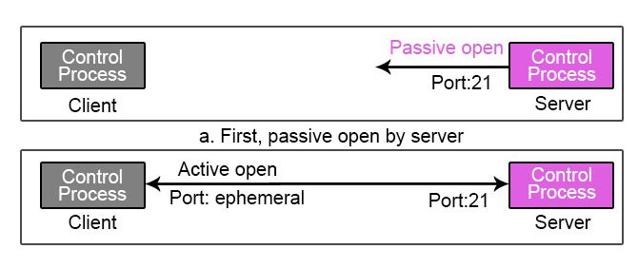
Fig1. Control Connection.

Fig 2. Communication between the client system and the server system FTP uses a control connection.
Data Connection - At the server site, the data connection uses well-known port 20 as shown in Fig 2.There are three steps to establish a data connection –
I. Using ephemeral port client issues a passive open. This step must be done by the client not the server because the client wants to transform the file.
II. Using the PORT command client sends this port number to the server.
III. When the server receives this port number from the client, it issues active open using well-known port 20
For transforming file over the data connection, the client must define the type of file which needs to be transformed, transmission mode, and the data structure. It solves the heterogeneity problem by defining these three attributes.

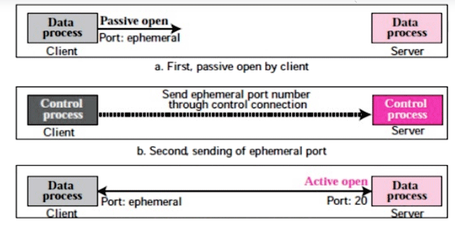
Fig2. Data Connection

